Listening Activity
Instructions: Use your QR code reader to take you to the EdPuzzle to listen to the people describe themselves.
Nesmah (Participant One – Easy):  https://edpuzzle.com/media/5cfed39b5bd3b540a82f192b  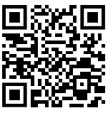 | Andrea (Participant Two – Easy): https://edpuzzle.com/media/5cff07c35bd3b540a8301923  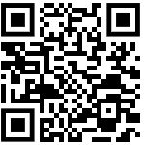
Mikey (Participant Three – Moderate): https://edpuzzle.com/media/5cff098f22cc5d40a29045d2  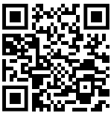 | Sheldon (Participant Four – Moderate): https://edpuzzle.com/media/5cff291375164240b63f8bed  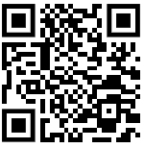
Roy (Participant Five Part 1/2– Difficult): https://edpuzzle.com/media/5d159793c88b564122e19323  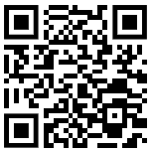 | Roy (Participant Five Part 2/2– Difficult):  https://edpuzzle.com/media/5d159e6fcbf83a41158eaf67  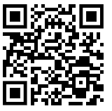
Les Vonkemen (Participant Six – Difficult):
https://edpuzzle.com/media/5d15a2805e8d56411b3af23b

