CLB 5/6: Anti-Racism – Public and Private Identity

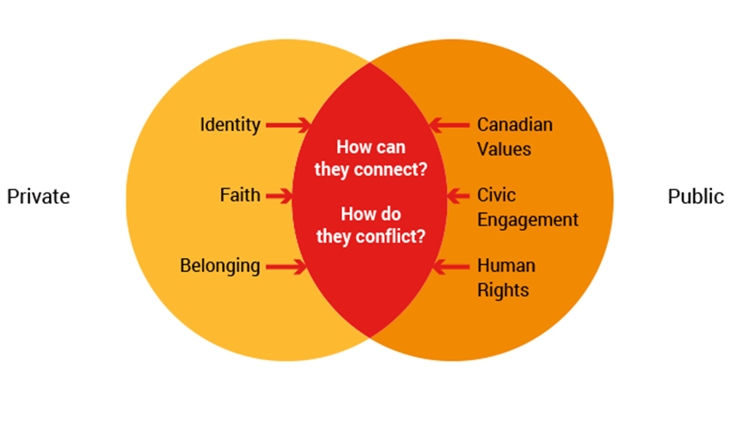
From Unit 6: Living Together in Today’s World, by Voices into Action, 2018.
Retrieved from https://www.voicesintoaction.ca/Learn/Unit6/Overview

