Name: Date:

CLB 3/4: Anti-Racism – Listening & Speaking “Who Are You?”
Instructions:
- Review the list of personal identity characteristics below.
- Based on how these have an impact on who you are – place a mark along the line, according to how significant it is in your life.
- Include other personal identity characteristics that are meaningful to you.

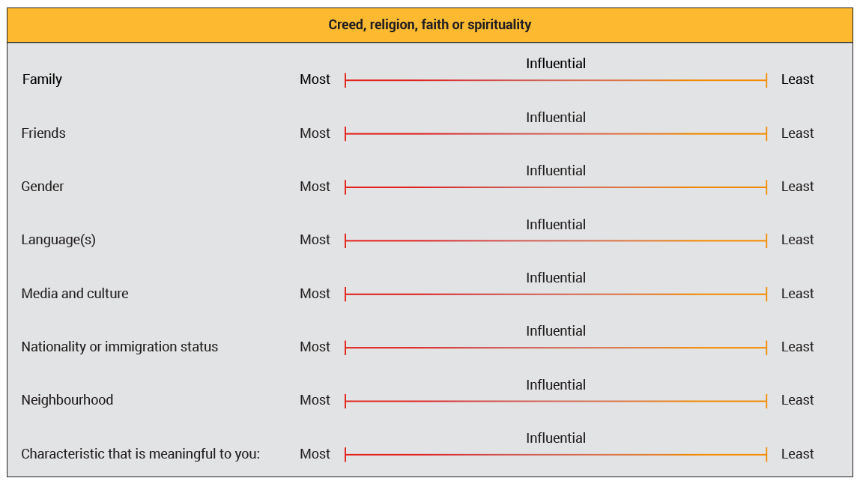
From “Voices into Action” – Unit 6 Living Together in Today’s World
https://www.voicesintoaction.ca/Learn/Unit6/Overview

