Name: Date:

CLB 3: Memory Game Vocabulary Review

Instructions: Match the word on the left to the picture on the right.
driver
cashier
teacher
mechanic |  | 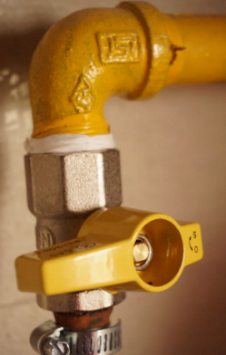
plumber
nurse
farmer
police officer

Instructions: Copy each word two times.
driver
cashier
teacher
mechanic
plumber
nurse
farmer
police officer

Instructions: Listen to your instructor and write the word he or she says.
1 |  | 5
2 |  | 6
3 |  | 7
4 |  | 8

Instructions: Unscramble the words below.
1. rateech
2. oelicp icfoerf
3. vreidr
4. ieahrcs
5. hicmcnae
6. prumelb
7. ruens
8. arremf

