Name: Date:

CLB 3: Introduction

Instructions: Answer the questions below.
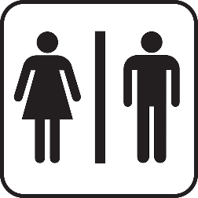
Q1. What does this sign mean?

Q2. Which room do you usually go in? Circle your choice.

Are you comfortable with your choice? Why?

Q3. Imagine you are a male (father). You have a small female child (daughter). Which room will you go in? Circle your choice.

Are you comfortable with your choice? Why?

Q4. Use the internet.
- Search “washroom signs”.
- What did you find? What do the signs show?

Q5. Use the internet.
- Search “gender neutral washroom sign”.
- What did you find?

- What do you think “gender-neutral” means?

Q6. Who can use gender-neutral washrooms?

Q7. How do gender-neutral washrooms help people?

Q8. Are there gender-neutral washrooms in your home country?

Q9. Where are the gender-neutral washrooms at your school or work?

  - How many gender-neutral washrooms are there?

  - Are there enough gender-neutral washrooms? Why or why not?

Picture Used

[male female washroom symbol] by OpenIcons, Public Domain, available at https://pixabay.com/vectors/restroom-public-restroom-rest-room-99225/

